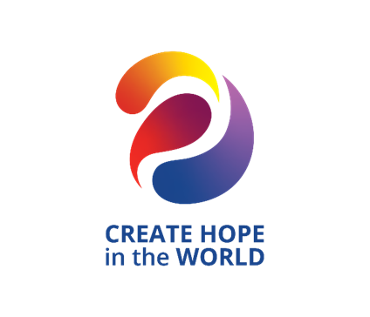

Deadline for Nominations is March 31, 2024

District 5080 Rotary Lifetime Achievement Award
This award recognizes District 5080 Rotarians who, through a lifetime of Rotary Service, have made the community locally and internationally a better place to live and work and have made significant contributions to Rotary and the community in the form of leadership and in the advancement of ideas consistently over a period of many years.
The District 5080 Rotary Lifetime Achievement Award may be presented to any active Rotarian (not an honorary member) who is a member of a Rotary Club in District 5080.
Criteria
The primary consideration for this award is outstanding service in Rotary over a sustained period. Other civic accomplishments may be considered, though these will be secondary in importance. The Five Avenues of Service, the Object of Rotary, and the Four Way Test should serve as a guide in evaluating a potential candidate.
The nominee will have demonstrated exemplary humanitarian service, with an emphasis on personal volunteer efforts and active involvement in helping others through Rotary. Service rendered by the nominee through Rotary must have been on a continuing basis. The award will not be given solely in recognition of one’s performance in an elected or appointed Rotary assignment. Personal financial contributions to The Rotary Foundation or any individual project are secondary considerations for this award.
Award
The award will be presented at the District Conference.

Nomination
Nominations may be made by any District 5080 Rotarian or Rotaractor.

Selection Process
Annually the Governor will select a committee of District 5080 Rotarians as the award selection committee. The Governor may choose to be a voting member of the committee. This team will work in conjunction with the chair of the District Awards Committee. When possible, past recipients of the award will be selected to serve on the committee.

Deadline
Nomination forms must be received by the chair of the awards committee by March 31, 2024.

Eligibility
The nominee must have consistently demonstrated support of the Object of Rotary through participation in service activities in all or most of the Five Avenues of Service: Club, Vocational, Community, Youth, and International.
An individual may only receive this award once, and the nominee must be an active Rotarian in good standing. The Governor, Governor-Elect, and Immediate Past Governor are ineligible to receive the award.

Nomination Form for District 5080 Lifetime Achievement Award

Name of Rotarian Being Nominated:
Please describe the reason this Rotarian is being nominated:
Attach Additional Sheet(s) As Needed.
Please refer to Selection Criteria Listed on Previous Page.
Feel free to add additional information or photos to support this
nomination.
Please send to: Steve Roberge, District Awards Chair
Coeur d’Alene Rotary Club
E-mail: stevenroberge25@gmail.com
Nominations must be received by Sunday, March 31, 2024
For the use of the Awards Committee only. Please do not write on this page.
Date Application Received:
Comments by Awards Committee:
Recommendation:

