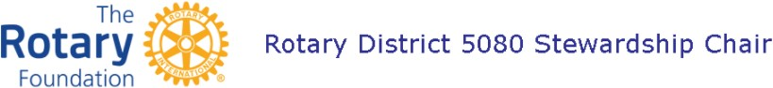

Club Grant Steward Duties

- Responsible for implementing, managing, and maintaining club qualification for each grant
- Ensure no actual or perceived conflicts of interest
  - report any conflicts as many can be worked out but this needs to be done before the grant goes forward etc
- Ensure that proper grant management practices are implemented and followed including the Financial Management Plan
  - needs to be following the grant as it goes along to make sure this happens
- Needs to be trained
- Cannot be a signer on the grant account nor serve on the club’s grant project committee
- Stewardship Rotarian can oversee more than one grant at a time

Financial Management Plan

- Club must have a written plan to provide consistent administration of grant funds
- Procedures to maintain a standard set of accounts, which includes a complete record of all receipts and disbursements of grant funds
- Ensures accountability of District Grant funds
- Ensures that signatories cannot be responsible for oversight of the project
- Ensure that bank account requirements are in place as per MOU

District Grant Training Qualification

- At least two of the three Club Project Committee Members (Club Signatures in DACdb) and the Club Grant Steward need to:
  - Attend the Annual D5080 Grant Management Seminar (in-person or online)
  - Pass the Grant Quiz
- The above individuals need to be qualified before submitting the grant

October 2023

