Fostering a Culture of Peace; Contributing to Social Justice Conference
Grand Forks, BC, April 30, 2022

In our small rural community of Grand Forks, BC, hosting an all-inclusive Peace Conference seemed a tall order but an urgent necessity. Upon reflection, we realized that we had deep relationships with family, friends and community organizations who share a strong commitment to world peace.

Land acknowledgement and an Indigenous prayer opened the conference. The presenters who followed, represented important collaborators:
- Rotary Club of Grand Forks: Murray Knox
- Doukhobor leader and life-long peace builder J.J. Verigin Jr
- Bahai Faith Community – Shelley Grandy

- The morning discussions lifted minds and hearts and built greater connections and commitment to fostering a Culture of Peace and Contributing to Social Justice, with small group ‘Talking Circles”, utilizing the ‘Talking Feather” process to respect, hear and honour every one of the over 45 participant’s contribution, during the two break out sessions.
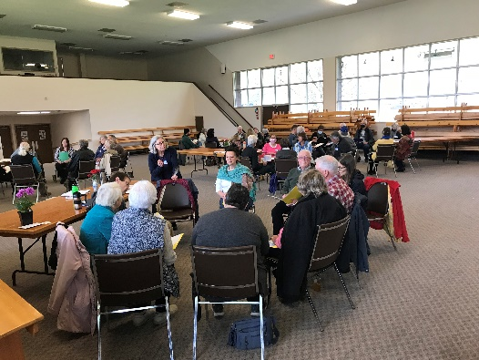
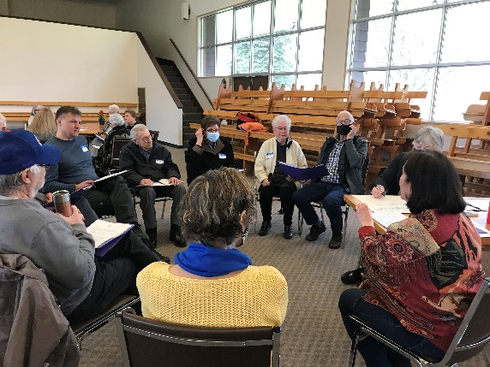

- Lunch was served to over 70 participants – some which came for only the afternoon session

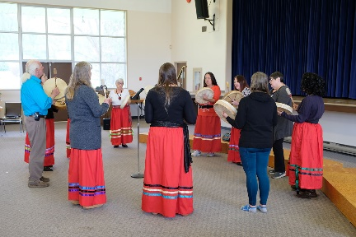
- The afternoon was dedicated to Music and Art for Peace which included an Indigenous led Drumming Circle, Grand Forks Choral Society, and the Doukhobor Community Choir, which lifted our spirits and minds.
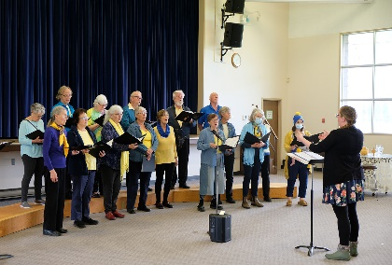
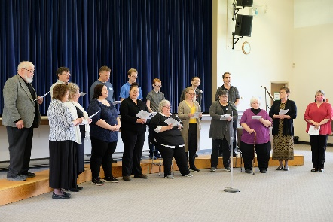
- It was evident that by the end of our conference there were elevated conversations taking place, not just in our ‘Talking Circles’, but at break times and during the lunch time as participants were awakening to the increased possibilities for fostering unity and serving their society alongside their neighbors and other fellow citizens.
- Due to illness, the two artists leading the Art for Peace mural project was postponed. This is taking place at the Farmer’s Market in Grand Forks on June 17. Children and youth are featured as contributors.

- A GFSS teacher enthusiastically shared her experience with her Global Citizenship Club and Social Justice class and asked them what they would like to see included in the Rotary Club of Grand Forks Time Capsule about Peace. They came up with over 30 ideas for our community, for our nation and for the world. The students are looking forward to greater involvement in September.

- With much gratitude to conference organizers Linda Wilkinson, Shelley Grandy and Maxine Ruzicka

- A Rotarian sent us his reflection on his personal experience:

“Taking into account this was my first peace conference I thought it went well. Personally, I appreciate the 'facilitator' format and the fact that the focus was on the very idea of peace and justice as opposed to concrete issues or examples. This made it a very safe place to discuss universal ideas around peace and justice. I learned that the Boundary area has a number of groups who are dedicated to or whose mission seems to be the advocacy of peace and the endeavour to manifest it through their work.
I was also happy that the USCC hall was used for this in-person - I feel it’s a good venue for conferences and concerts . . . “.

