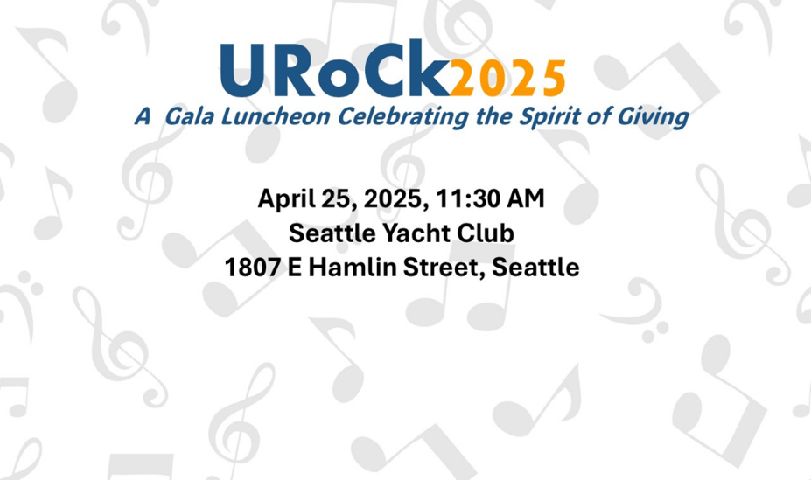

**TICKET ORDER FORM**

***Please check/circle/highlight the appropriate box and fill in blanks, including guest information on page 2 or backside of printed copy.***

***Guest Information:*** *Name, Email address, cell phone number, if no cell phone, please provide landline number, meal preference:* ***filet mignon (GF), grilled salmon (GF) or butternut squash ravioli (vegetarian).***

***Use Note in registration comments:***  *any food allergies and seating preferences.*

**____________10 In-Person Tickets to UDRC April 25, 2025 Fundraiser and Gala Luncheon, $1100.**

Includes 1 drink ticket per person for a glass of wine, beer. or a beverage without alcohol. No Host Bar. Free Parking.

**____________8 In-Person Tickets to UDRC April 25, 2025 Fundraiser and Gala Luncheon, $888.**

Includes 1 drink ticket per person for a glass of wine, beer, or a beverage without alcohol. No Host Bar. Free Parking.

**____________5 In-Person Tickets to UDRC April 25, 2025 Fundraiser and Gala Luncheon, $580.**

Includes 1 drink ticket per person for a glass of wine, beer, or a beverage without alcohol. No Host Bar. Free Parking.

**____________Individual Event and Dinner Ticket, April 25, 2025 Fundraiser and Gala Luncheon, $125.**

Includes 1 drink ticket per person for a glass of wine, beer, or beverage without alcohol. No Host Bar. Free Parking.

## Purchaser’s Name, please print above the line

## Address:

## City, State, Zip Code Cell Phone Number OR Landline

## Email Address (print above line) Comments: seating requests/food allergies, note above

Enclosed is my check for $______________________ made payable to **University Rotary Service Fund.**

Please charge my credit card $ ______________. Contact [sallypor789@gmail.com](mailto:sallypor789@gmail.com) to complete transaction or

pay online at: <https://auctria.events/udrc2024fundraiser>.

You can also deliver this completed form at a club meeting or send by mail to UDRC, PO Box 31125, Seattle, WA 98103. Questions, please contact: Sally Porter Smith, [sallypor789@gmail.com](mailto:sallypor789@gmail.com)

**Guest Information for Table Purchase for ________________________________(purchaser’s name)**

**Note any food allergies, if identified**

Guest Name

Email Address

Cell Phone if available/landline Dinner Choice: Filet Mignon , Salmon (GF), Ravioli (Vegetarian)

Guest Name

Email Address

Cell Phone if available/landline Dinner Choice: Filet Mignon , Salmon (GF), Ravioli (Vegetarian)

Guest Name

Email Address

Cell Phone if available/landline Dinner Choice: Filet Mignon , Salmon (GF), Ravioli (Vegetarian)

Guest Name

Email Address

Cell Phone if available/landline Dinner Choice: Filet Mignon , Salmon (GF), Ravioli (Vegetarian)

Guest Name

Email Address

Cell Phone if available/landline Dinner Choice: Filet Mignon , Salmon (GF), Ravioli (Vegetarian)

Guest Name

Email Address

Cell Phone if available/landline Dinner Choice: Filet Mignon , Salmon (GF), Ravioli (Vegetarian)

Guest Name

Email Address

Cell Phone if available/landline Dinner Choice: Filet Mignon , Salmon (GF), Ravioli (Vegetarian)

Guest Name

Email Address

Cell Phone if available/landline Dinner Choice: Filet Mignon , Salmon (GF), Ravioli (Vegetarian)

Guest Name

Email Address

Cell Phone if available/landline Dinner Choice: Filet Mignon , Salmon (GF), Ravioli (Vegetarian)

Guest Name

Email Address

Cell Phone if available/landline Dinner Choice: Filet Mignon , Salmon (GF), Ravioli (Vegetarian)

Guest Name

Email Address

Cell Phone if available/landline Dinner Choice: Filet Mignon , Salmon (GF), Ravioli (Vegetarian)

