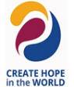
Rotary Club of the University District
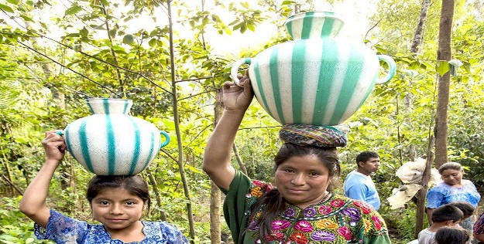  Club Background  Founded in 1939, University District rotarians have been making an impact both locally and internationally for decades. Our club is over 100+ volunteers strong and have supported local and world community projects that exemplify the motto “service above self.” There are seven areas of focus that reflect critical humanitarian issues and needs that guide our work: Peace and Conflict Prevention, Disease Prevention and Treatment, Water and Sanitation, Maternal and Child Health, Basic Education and Literacy, Economic and Community Development, and Environment. The following are highlights of our many Club projects.  Community Services  - Founded Rotary First Harvest, a District 5030 project supplying produce to food banks throughout the state, recognized by Rotary International as one of "100 Exemplary Rotary Projects"  - Prepare meals at the Ronald McDonald House for children undergoing critical medical treatment and their families  - Supported the purchase of a van for the use of Ronald McDonald House patients and families.  - Provided funds for the redesign and remodel of the family gathering area at Ronald McDonald House  - Supply car seats for needy newborns in the Buckle-Up Baby Program at the UW Medical Center  - Purchased books for the John Stanford International School library  - Equipped the first Medic 1 Unit in the University District |  |  | - Offer annual scholarships for college students.  - Provide equipment for the food bank at Family Works in Wallingford  - Supply musical instruments and supplies for low-income youth under the Music4Life program  - Warm coat distribution for people in need in the University District

International Services
- Donated new wheelchairs to Guatemala, Ethiopia, Fiji, Uganda, Vietnam, and Peru
- Support clean water projects in Vietnam, Ethiopia, Mexico, Nigeria, and Uganda
- Furnished English lab equipment to a girls' high school in Chile
- Funded reconstructive surgery and vocational rehabilitation in Nepal, along with computers for public schools, birthing kits, and school toilets in rural areas
- Helped build a three-classroom elementary school for 200-300 students in rural Vietnam.
- Funded cleft palate surgeries for children in Peru and Guatemala
- Funded orthopedic services for at least 100 mobility-disabled persons in Bangladesh
- Assisted the Santa Barbara Chile Rotary Club in purchasing heating stoves for rural schools damaged in the earthquake of 2010
- Provided pediatric respiratory care equipment through Breath of Life in Vietnam
- Support orphans in Vietnam through the Teach Me to Fish Program
- Provide cardiac medical equipment to the Children's Hospital in Cuba

