Accessing Reimbursement Forms the Short Way
Click+control on the following link to download the form for reimbursements under $100.
https://www.dacdb.com/index.html?FW=SF&BaseDir=8FF3478D3B1A0466DB7CCC781D02171B&Path=123/Committee/800107033/2022%20RCMI%20Reimbursement%20Form%20under%20100.docx
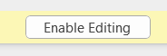
The file will download and you can find it in the lower left hand corner of your screen.
After opening the file, You may need to click on
in the ribbon at the top of the page to use the file.

Click+control on the following link to download the form for reimbursements over $100.
https://www.dacdb.com/index.html?FW=SF&BaseDir=8FF3478D3B1A0466DB7CCC781D02171B&Path=123/Committee/800107033/2022%20RCMI%20Reimbursement%20Form%20Preapproval.docx
The file will download and you can find it in the lower left hand corner of your screen.
After opening the file, You may need to click on
in the ribbon at the top of the page to use the file.
(there’s more on the next page)
Accessing Reimbursement Forms the Long Way
The web address is http://dacdb.com/index.html (control+click on this link)
If you are not familiar with DACdb, follow the instructions in DACdb quick start guide to login.
Log into DACDb
Click on My Club located in the tabs at the top of the page.

Click on

Find RCMI Board of Directors in the list and Click on it.

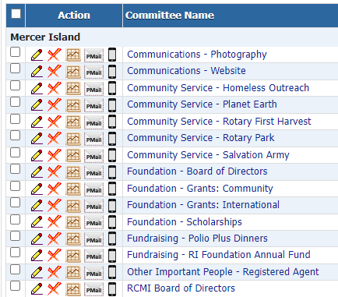

In the upper right hand corner you will see a row of grey squares.
Click on square labeled “Files.”

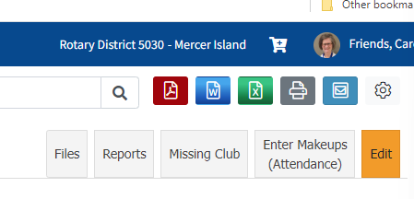

Click on the Secure Tab. You will see a list of files. To download a file, click on the file you want. It will show up in the lower left hand corner.
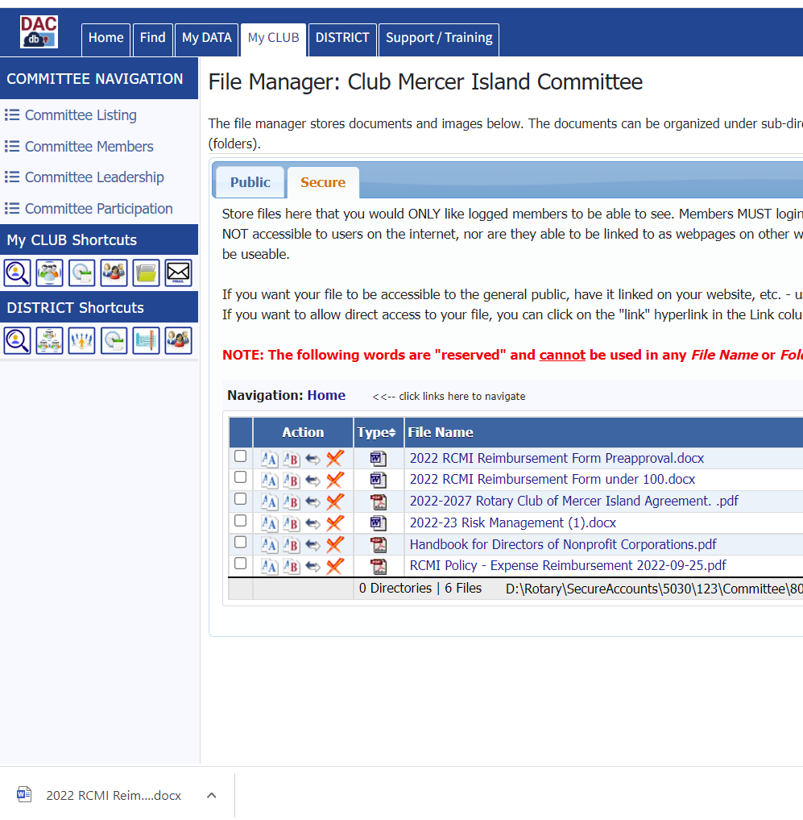
Click on the file to open it. Once the file is open, you may need to click on to save the file.

