PO Box 1432  Kent, Washington 98035  February ___, 2018 | 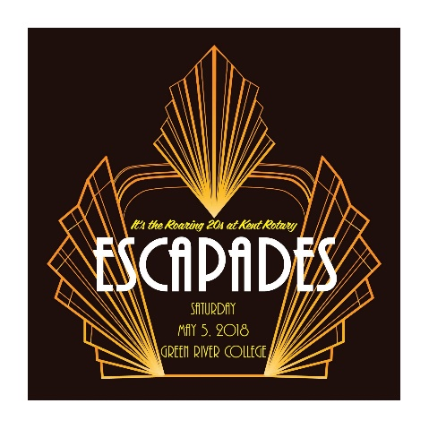
Dear Friend,
Speakeasy, Gatsby, Prohibition! All bring back thoughts of the Roaring 20s – and The Rotary Club of Kent has tapped into those images for its 2018 Escapades Dinner-Auction. The Roaring 20’s is the theme, and the evening promises to be packed with excitement, fun, and goodwill. This is our flagship fundraiser, and we expect 300 people to attend, with over $100,000 being raised! Just imagine the difference this will make in the lives of people in our Kent and World Communities.
Now, we need YOU to join in. Our auction is made up of donations from individuals, companies large and small, and organizations. Experiences and unique items are in high demand, but guests also look for handcrafted items, promotional items, and gift certificates. They all make this event the very best possible. With such a wide variety of items available, our guests are drawn to opening their hearts and wallets to support causes such as:
- College scholarships for top students in the Kent School District.
- Vocational scholarships for students choosing careers in the trades.
- “Backpack Buddies” providing weekend food so students are ready to learn on Monday.
- Rotary First Harvest, which connects farmers and volunteers to supply local foodbanks.
- The annual Fishing Experience for hundreds of children and their families.
- Local nonprofits and their direct work in our community.
We also need YOU in another important way. Please plan to join in the fun of the Roaring 20s on May 5, 2018 from 5:00 to 9:30 p.m. at Green River College’s Lindbloom Student Center. Parking is free, and so is the fun. We’d love to have you join us for this fabulous event, and I hope to connect with you soon. Information, including registration and donations, can also be found at http://www.kentrotary.com/escapades.php.
The Rotary Club of Kent Foundation is a 501(c)(3) tax-exempt organization (EIN 91-1522960). You will receive a receipt that provides details about your donation and any purchases made that evening.
On behalf of the members of The Rotary Club of Kent, and Rotary’s 1.2 million volunteer members worldwide, please accept our sincere thanks for your generous support!
Name ___________________________________
Phone ___________________________________
Email ___________________________________

