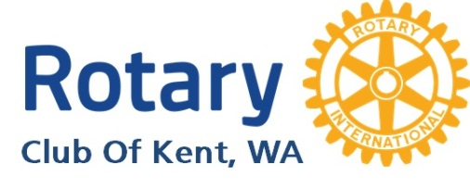
Year in Review (2013-14)

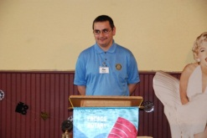  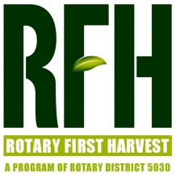  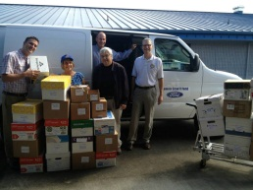  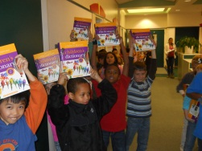  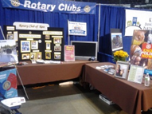  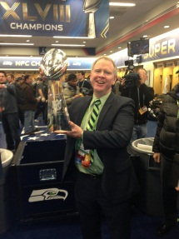  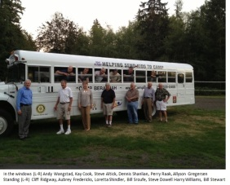  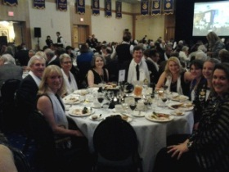  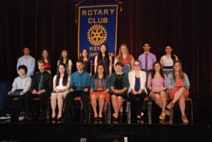  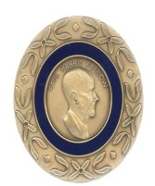 | - Budget from Escapades: Dream Big  - Theme: Engage Rotary, Change Lives  - Greeter Tim  - Publicity  - Kent Reporter  - Social media  - Website  - Interact at Kentridge first full year  - Rotary First Harvest  - $1,000 grant  - Volunteered monthly  - Hungry Soul Café  - $4,000 for equipment  - Includes District Grant & other clubs  - Volunteered monthly  - School Supply Drive; 62 boxes, 2 schools  - Project Ethiopia  - Global Grant  - Support from other clubs  - Annual Luncheon at Kent Senior Center  - Students of the Month  - Dictionary Project w/ Sunrise & Covington  - Ethics Class at Kentridge High School  - Kent Expo with Chamber of Commerce  - Rotary Night at ShoWare Center with the Thunderbirds  - Great programs  - Seahawks plans for success  - Cougars in Antarctica  - Membership  - Tough decisions  - Added 5 new members  - Improved attendance to over 80%  - Fellowship  - Picnic at Camp Berachah  - Thirsty Thursdays  - Continuity Committee  - Increase emphasis on vocational  - Explore alternative Escapades management  - District Conference in Vancouver  - 7 members attended  - 6 members on conference committees  - Literacy award  - Rotary Academy graduates  - Amy Hobson & Nathan Box  - Escapades – Hollywood!  - Record numbers  - New auction software  - Fishing Experience  - Scholar Recognition Event  - Eleven $1,500 scholarships  - Vocational Scholarship Luncheon  - Six $1,600 scholarships  - Installation banquet  - Roast of Dawn’s transition from bad girl to club President  - Attended by multiple district representatives including District Governor, Ezra Teshome  - Presidential Citation received  - Perfect attendance by 12 (273 yrs)  - Rotarian of the Year: Kay Cook  - Foundation giving  - EREY at 91%  - multiple new Paul Harris levels  - World Cup viewing party  - 14 -15 theme: Light Up Rotary | 