proudly presents
SLCA Christmas in the Village “Gear Up for Giving!” Pop Up Market
Saturday, December 10th from 11am to 3pm

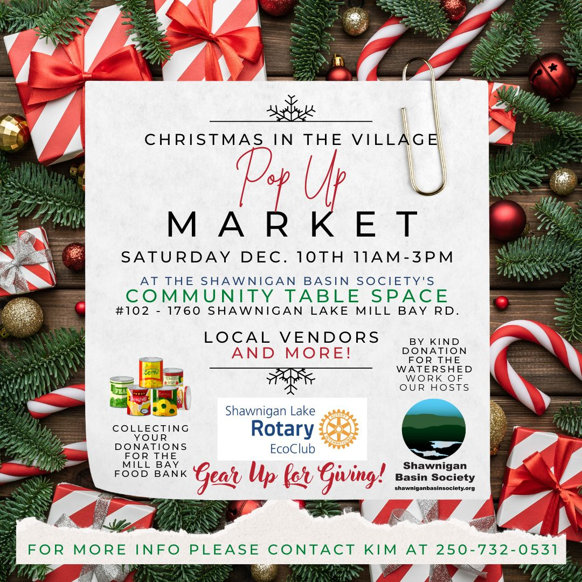
Advertising in the Shawnigan Focus, the Shawnigan Events Forum, and shareable FB Event Post - https://www.facebook.com/events/5524238871005489

We're so excited for "Christmas in the Village" on Saturday, December 10th! Meet local artisans of all ages, and special guest Chris Lumley of the Shawnigan Cobble Hill D&D Club!

Help support our kind hosts at the Shawnigan Basin Society with any amount, and please bring your non-perishable donations for the Mill Bay Food Bank!

Vendor Information

This Pop Up Market is a first for this space and features a stunning room-length wood table, an environmentally-friendly vibe, electrical outlets, chairs galore, a kettle with tea and instant coffee provided, and a washroom. Music and goodies are expected as well!

It's "By Donation" for participants and guests alike - we will have green donation bin(s) for items for the Mill Bay Food Bank and a cash donation container for the Shawnigan Basin Society's ongoing watershed stewardship work. Donations to our Shawnigan Rotary EcoClub can be sent by e-transfer with auto-deposit to ShawniganRotaryEcoClub@gmail.com with our gratitude!

We'll be joined by local artisans and makers and their families, several of our club members and their specialties, our hosts SBS with their "Lovin' Lake Life" brand clothing and water bottles, and special guest Chris Lumley who hosts D&D adventure game campaigns in this space.

The Rotary EcoClub secretary-president Kim and friends will be at your service, especially with yummy gingerbread from KimsGingerbread.com ...we look forward to sharing our enthusiasm and treats with you!

Location and Parking: Shawnigan Basin Society’s Community Table Space
#102 - 1760 Shawnigan Lake Mill Bay Road
(conveniently located across from
Shawnigan House Coffee & Chocolates and Oma’s Bakery)
Parking is available behind the building and on surrounding streets
Overflow parking for the village is at the SL Community Centre

Decorating will be happening on Friday, December 9th (time tba, 3pm-ish), Kim 250-732-0531

Setup is minimal as the room already has an enormous table that allows for a collective craft-charcuterie-style shopping experience! We recommend you to bring your items in totes that can be stored under this massive table. You can choose to bring displays that allow for height on the table, and any other accessories such as battery-powered lights are very welcome!

Please plan to process your own payments with a float and any terminal devices you’ll need (WiFi instructions are posted inside the room). We will supply you with “snowflake tokens” for each transaction you make, and you’ll also be wearing a snowflake and a nametag to identify you as a vendor.

We invite you to engage with each other and learn the stories of the items brought and businesses represented. This will be an interactive time of mingling and answering questions from shoppers. You can even “shop” each other’s goods and practice those Q&As 🙂
Bring your contact info for a card swap, and use this opportunity to take photos and closeups - everything is sure to look festive! * * * Hint: dust off your handcut paper snowflake skills * * *

We plan to have both entrances propped open a bit for fresh air and to create that inviting feeling for customers - please dress accordingly!

Do you have suggestions and any other questions not addressed here? Please reach out and we’ll update the event information.

Gratefully,

Kim Barnard
EcoClub Secretary-President-StoryGatherer
250-732-0531 text/mobile

The Rotary Club of Shawnigan Lake EcoClub
Chartered June 2021 | Sponsored by the Rotary Club of Duncan
Facebook - Twitter - Instagram - YouTube
ShawniganRotaryEcoClub@gmail.com
www.ShawniganRotaryEcoClub.ca

We are Canada’s first Rotary EcoClub, part of a growing network of EcoClubs worldwide. We are based outdoors and devoted to environmental stewardship and sustainability practices. We believe in honouring our First Nations and other community stakeholders, actively networking to build collaborative relationships and sharing knowledge, and developing strategic implementation of our Think Shawnigan community assessment recommendations through hands-on community projects. Visit our website at https://shawniganrotaryecoclub.ca/learn-more/

