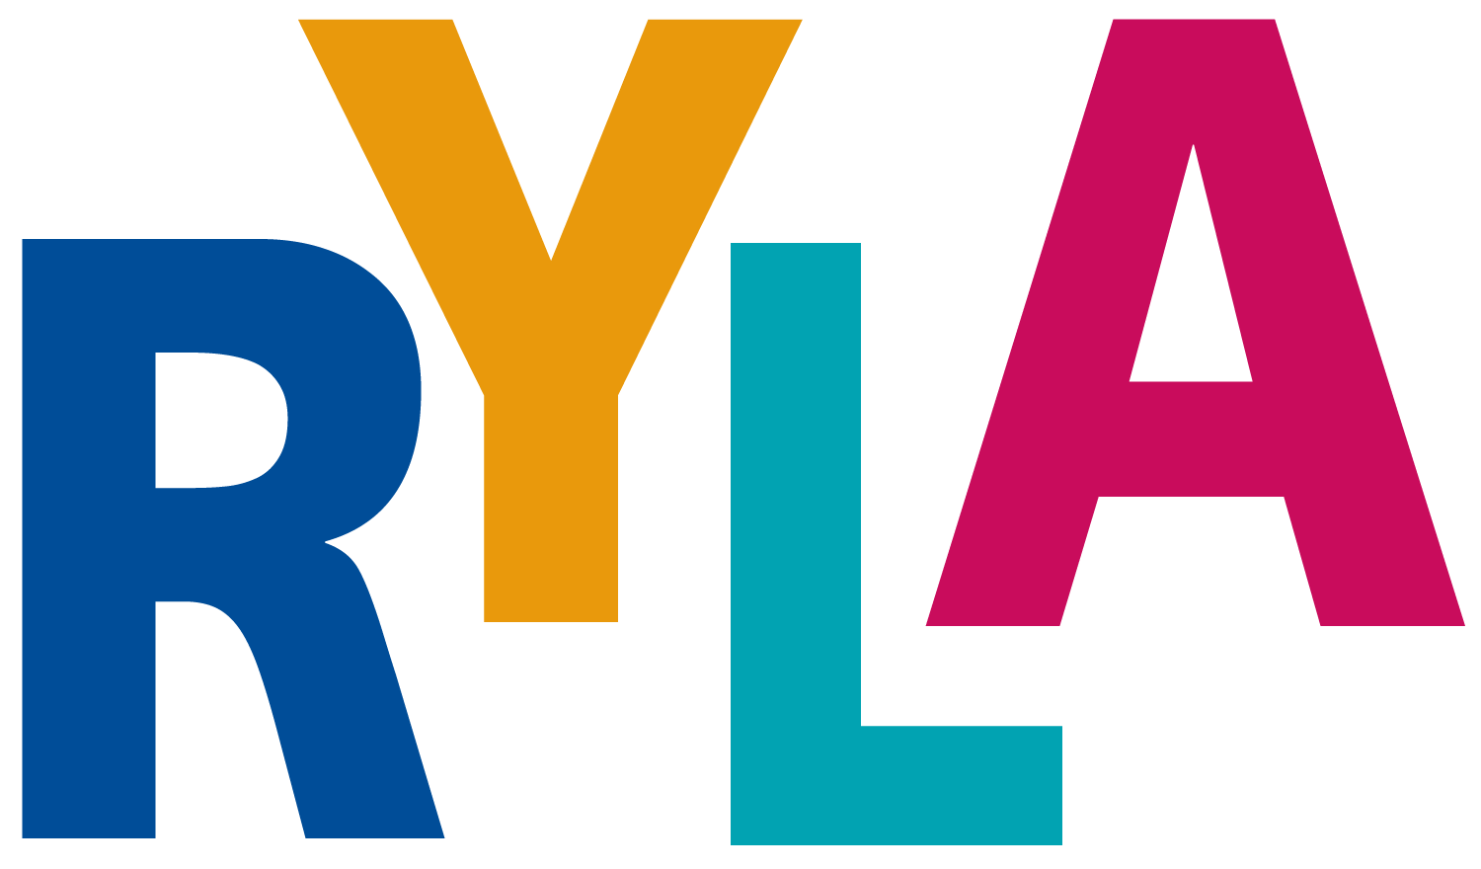
District 5020

Vancouver Island, November 18-20, 2022

APPLICATION for RYLA VI – Rotary Youth Leadership Awards Vancouver Island

To be completed by sponsoring rotary club for each student

Sponsored by Rotary Club of

Rotarian Contact

Telephone Email

Name: | Name on badge: |  |  | Gender
Address:

Province/State |  |  | Postal Code/Zip Code:
Cell Phone: |  |  | Age at start of event:
Email address: |  |  | High School
Interact Club Member Yes No |  |  | T-shirt size:
Next of Kin: |  | Email:
Home phone: |  | Cell Phone:

Yes, I want to attend RYLA. I understand that I will be bringing personal belongings and that neither Camp Qwanoes nor RYLA are responsible for any items lost or stolen while attending this conference.

(Signed)

PLEASE NOTE: THIS FORM ALONG WITH THE PARTICIPATION RELEASE FORM MUST BE COMPLETED AND RETURNED AS SOON AS POSSIBLE TO EITHER YOUR SCHOOL COUNSELOR OR ROTARIAN REPRESENATIVE.

Family Doctor Telephone#
(Canadian Students) Provincial Medical Plan Number / / _/

(USA Students) Medical Plan Carriers Name
Plan # Telephone #

Out of Country Medical Coverage Carriers Name

Plan Number
Out of Country Medical Plan Carriers Telephone Number

Dietary Needs, Allergies, etc.

_

Medical Conditions

_

Prescription medicines you will have with you _

_

Special Assistance or any other information _

_

In the event of an emergency, I authorize the above camp staff and/or Camp Qwanoes and/or BC Emergency Services to arrange for emergency transportation and/or emergency medical care.
In Case of Emergency, please notify:

Name Number Relation
Name Number

Relation

Signature of Participant Date Printed Name

(Signature of Parent/Legal Guardian) Date Printed Name
*Parent or legal guardian must also sign for participants under 18 years of age

