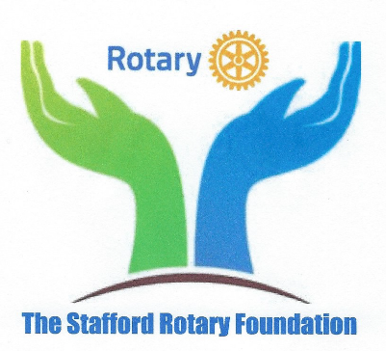
The Stafford Rotary Foundation
CHAIRMAN’S LETTER

Dear Fellow Members of The Stafford Rotary Foundation:

Another Rotary year has passed and I am pleased to report that your Foundation has once again admirably fulfilled its mission to “Build a Better Community and World Through Humanitarian, Educational, and Charitable Endeavors” in support of The Rotary Club of Stafford. As you read this report, I think you will agree that through your willingness to share your time and treasure, we have made significant steps forward through Rotary’s Avenues of Service. I am also happy to report that our membership increased during the year from 33 to 38 members. Giving to the Foundation was strong and our Casino Night fundraiser was again successful in providing support for worthy projects. Also, we added to our resources through our very successful Capitol Steps fall fundraiser. Lastly, in addition to my thanks to you, our members, I would like to express my gratitude to the Foundation’s Board of Trustees for their hard work and dedication this past year. Their ongoing work to modernize our operation will bear dividends for many years to come.

Yours in Service,
Debra

Board of Trustees 2018-2019
Debra Schleef, Chair
Michael Smith, Vice-Chair, Ex Officio
Don Duckworth, Secretary
Linda Knecht, Treasurer, Ex Officio
Nelda Mohr
Jake Almborg
Shawn Huwar, Ex Officio

The Stafford Rotary Foundation
ANNUAL REPORT 2018-2019

The Stafford Rotary Foundation had a busy and productive year in 2018-19. Among the highlights was our very successful participation in the Meals of Hope Project where we prepared over 40,000 meals to assist people in our community with food insecurities. Other notable projects included our annual provision of dictionaries to every third grade student in Stafford County; continued Interact presence in Stafford and Mountain View High Schools; Restarted the University of Mary Washington Rotaract Club. The Foundation Board continued to dedicate time and energy during the year to refining and extending the organization with emphasis on updating and modernizing operating procedures and policies. This effort is on-going as the Foundation works to better serve The Rotary Club of Stafford and the community.

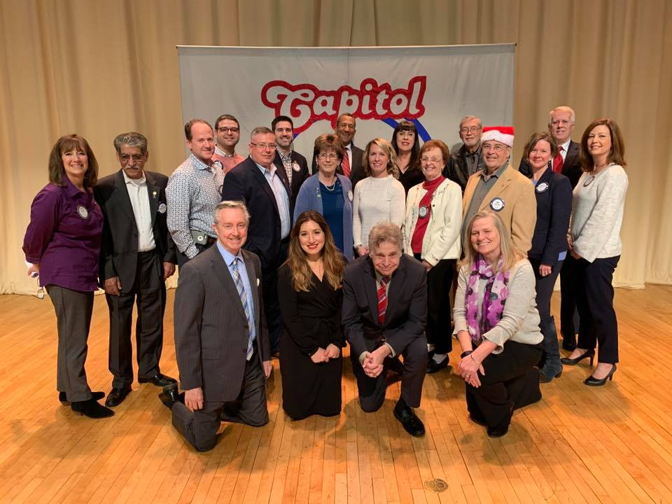
About Us
The Stafford Rotary Foundation is a
Virginia Non-Stock Corporation chartered
May 17, 2001. It is a 501(c)3, non-profit
organization established to support The
Rotary Club of Stafford build a better
community and world through
humanitarian, educational, and charitable
endeavors. It supports its mission and
purpose through soliciting, receiving and
administering public contributions and
other tangible support. The Foundation
membership is composed of active and
honorary members of The Rotary Club of
Stafford who both contribute financially to projects and through their participation
and hands-on involvement. The Rotary International motto “Service Above Self” exemplifies the commitment we share to make our community and world a better place. The Stafford Rotary Foundation Mission – “To support The Rotary Club of Stafford build a better
community and world through humanitarian, educational and charitable endeavors” – is channeled through four charitable Avenues of Service that are fundamental to Rotary activities and contributions. In addition to the thousands of hours spent by the members of The Rotary Club of Stafford in serving the community, The Stafford Rotary Foundation distributed $43,700 in support of the following avenues of service (almost twice as much as last year!):

Youth Service
Recognizes the importance of empowering youth and young professionals through leadership development programs. The Stafford Rotary Foundation spent $18,705 on the following projects for Youth Service:

§ Dictionaries for 3rd Grade Stafford County students.
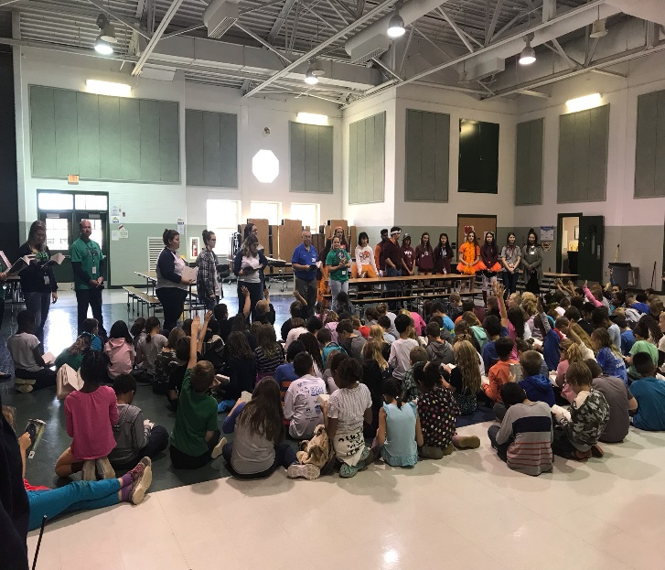
- Interact Clubs Decorated a Tree in Support of
LoisAnn’s Hope House.
§ Interact Clubs at Mountain View High School;
Stafford High School; and Oberle School.
- Restarted Rotaract Club with UMW
§ Essay Contest for Middle School Students
§ Speech Contest for High School Interact School
Participants.
§ Rotary Youth Leadership Awards (RYLA).
§ Riverside Youth Theater Summer Camp.
§ Academic Scholarships (Stafford, Mountain View,
Colonial Forge, Jonathan Herrera).

Vocational Service
Calls on every Rotarian to work with integrity and contribute their expertise to the activities and needs of society. Also, it encourages the pursuit of projects related to such areas as career planning, vocational training and the promotion of high ethical standards in the workplace. The $750 spent supported the following projects:

§ Outstanding Community Service Awards.

Community Service
Encourages every Rotarian to find ways to improve the quality of life for
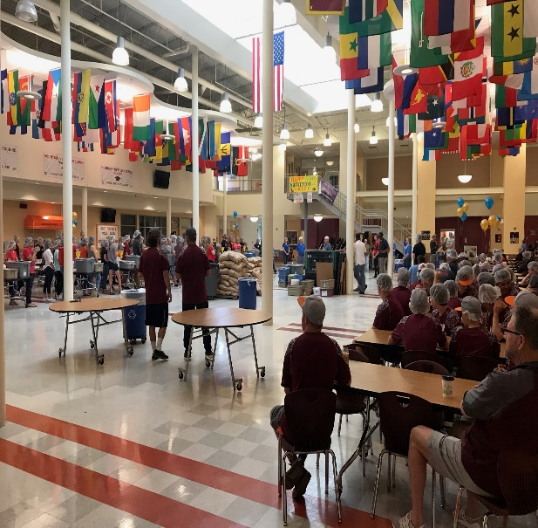
people in their communities and to serve the public interest. The Stafford Rotary Foundation spent $18,100 in funds for the following projects:

§ Decorated Tree in Support of LoisAnn’s Hope House.
§ Stafford Junction – Children’s Meals.
§ Meals of Hope Project- 40k Meals Packaged
§ Ringing of the Bell for Salvation Army
§ Area Agency on Aging Meals
- Operation Warm with Stafford County Public Schools
- Back to School Supply Drive with SPCS
§ Stafford Junction in Kelsey’s Memory

International Service
Exemplifies our global reach in promoting goodwill, peace and
understanding. Many International projects are designed to meet humanitarian needs in the
developing world or to support relief and recovery efforts in the wake of disasters. The Stafford
Rotary Foundation spent $6,145 in support of the following:
§ Supported Two Global Grants
§ Rotary International Foundation, Polio Eradication.

Club Statistics
- 100% Sustaining Member Club – everyone contributed minimum of $100 each
- Paul Harris Society Members: 16
- Paul Harris Fellows: 26
- Multiple Paul Harris Fellows: 18
- Rotary Direct Donors: 15
- Major Donors - 5
- Benefactors: 3
- Bequest Society: 2
- Annual Fund contribution: $19,669.34 (112% of $17,500 goal)
- Annual Fund Per Capita: $596.04 (#5 in district)
- Polio: $3,600 (#7 in district)
- Year to date total contributions to RI: $23,474.34 (10 District top 10 Annual Fund club)

