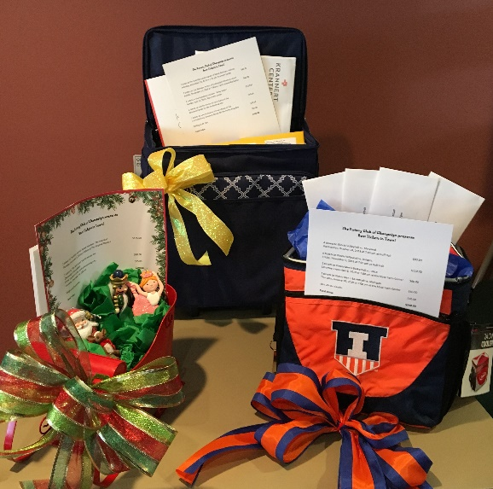
The Rotary District 6490 Basket Auction for PolioPlus will be held virtually from September 18-25. We are asking each Rotary club to donate a theme basket or other items for the auction.*
Please email a picture of your club’s basket and the following information to Janet Ellis-Nelson at janetnelson1994@gmail.com on or before August 25.
We would like clubs to bring their baskets to the District Conference at Richland Community College in Decatur on September 25 so they can be displayed during the conference. Each club will be responsible for getting their basket to the winning bidder after the conference, if the winner is not in attendance at the conference.
*Clubs may donate single items or gift certificates instead of a basket.
Club Name: _______________________________
Estimated Basket Value: $___________________
This basket includes: (Please list the contents of the basket.)

