Mid-America PETS
Room Assignment
Adding members to rooms in DACdb
Version 1.6
3-21-2019

Contents
Getting Ready 1
Completing Registration 1
Members Entered as Guests 1
Invalid values in Backroom 1
Rooms Module 2
Auto Assign 2
Idea Exchange Room Assignments 3
Run Initial Room Assignments 5
Non-Native Districts 5
Minimum Club Size for Large Club Room 5
Multiple Members from the Same Club 5
Clear Selected Room Assignments 5
PE’s from Non-Native Districts 6
Copy room assignments to subsequent Idea Exchange Sessions 6
Apply ROOM CatCodes to Badge 9
Clear ROOM Catcodes on Badge 11
Assign members to other rooms 11
General Session (attended by all registrants) 11
District sessions 13
Assigning Members to Electives 14
PDG Reunion 15
General Session I (Concurrent sessions with PN’s and PND’s in a separate session) 16

Getting Ready
The following tasks must be completed prior to starting the process of assigning members to rooms in DACdb.

Completing Registration
Complete the registration process for all members prior to starting to assign members to rooms, especially PE’s, PN’s and PND’s. Using the MyEvent’s“My Agenda” feature that allows each member to view a personalized agenda requires us to assign every registrant to multiple rooms so they are assigned to every room / session they are supposed to attend.

Members Entered as Guests
Clean up the members registered as zGuests (not associated with their home club) who are members of one of our native districts and reconnect them to their DACdb membership profiles. This is necessary for name badges to be complete with club and district information and for club size room assignments.

Invalid values in Backroom
Clean up the backroom values in the Full Reg fields especially all non-standard manual entries for any PE’s, PN’s or PND’s. If in future years other registrant types are assigned to Idea Exchange rooms, include those backroom values in the list of values to clean up.
Note: it is advisable to avoid manually entering values in the backroom that are not values that would be entered automatically by the registration process. These values can be found in the individual questions.

Rooms Module
These instructions assume all the rooms needed for MAPETS have been set up. From the Edit Event screen select “Rooms” from the left-hand menu. (Figure 1 below)
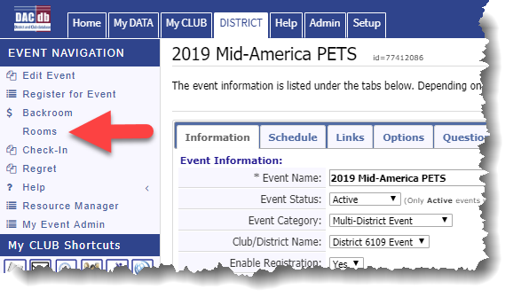
Figure 1

Auto Assign
From the Event Room Listing select Auto Assign to access the various options for assigning members to rooms.
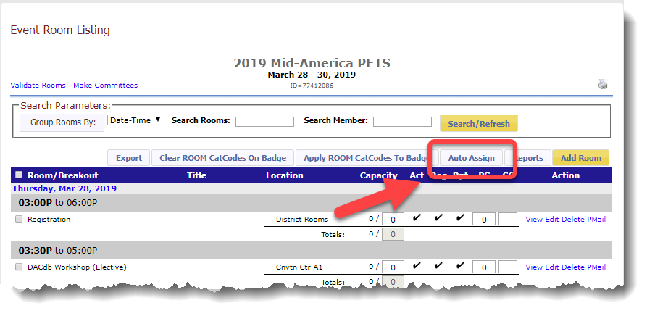
Figure 2

Idea Exchange Room Assignments
Idea Exchange Room Assignments: This process requires some experimentation and manual fine tuning. You can “redo” the room assignments as many times as necessary prior to running the Apply Room CatCodes to Badge routine that copies assigned room CatCodes to the Cat Codes field in the backroom which is required prior to printing badges.
Option: 3b) Allocate (Assign) Registered Members to Room by Club Size (aka PETS Membership)
Assign ONLY IF Value = “PE,PN,PND”
Select multiple fields, press and hold the Ctrl key while clicking on each field name that can contain these values
For 2019 select the following values for the “in question(s)” selection box
4-Full Reg 5750; 5-Full Reg 6110; 6-Full Reg 6150; 8-Full Reg 6170
Do not select the 7-Full Reg Outside question. Any registrants in this category will be added to room(s) manually. (See Figure 3 below)
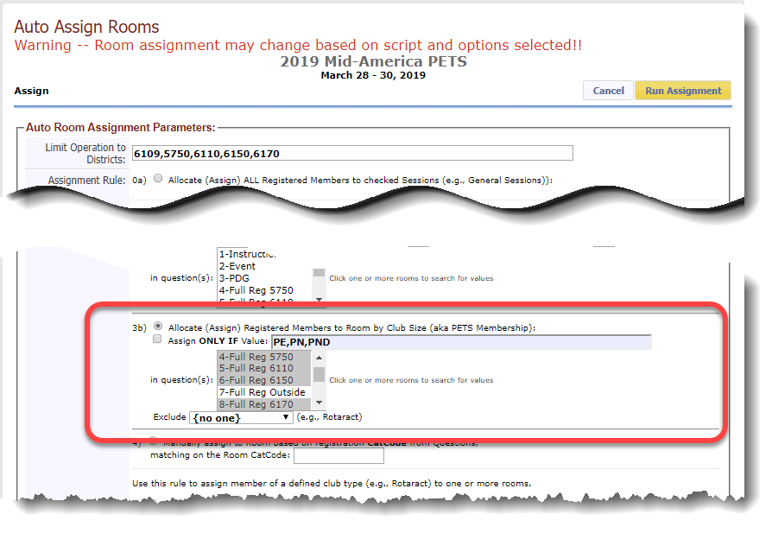Figure 3
Scroll to the bottom of the screen and click Select Rooms OFF to deselect all rooms.
Then click on the box next to the 10:45 AM description for the Idea Exchange Session I This will select all the Idea Exchange Session I rooms. (See Figure 4 below)

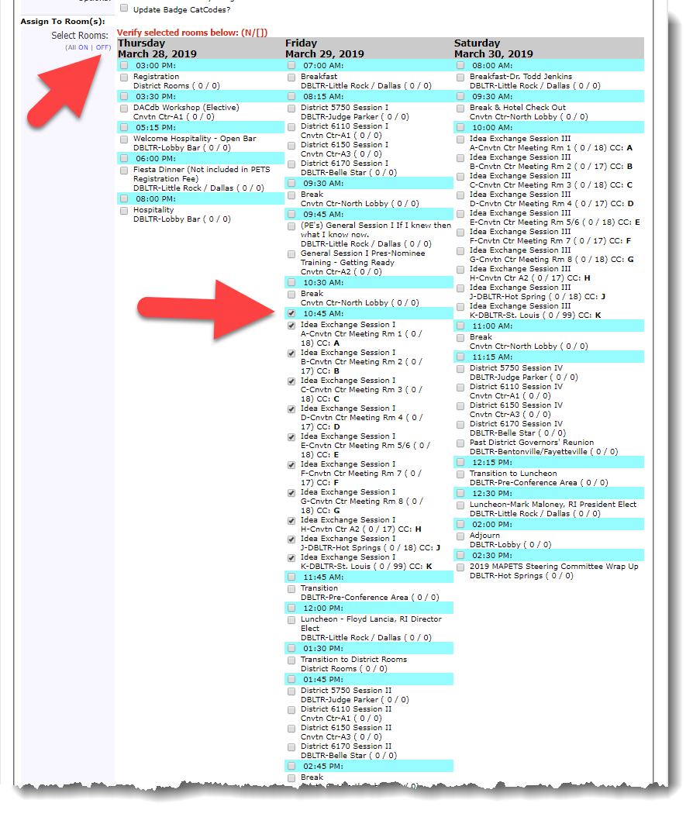
Figure 4
Click the yellow Run Assignment button at the top of the screen.

Run Initial Room Assignments
You will need to run a initial room assignment to determine which rooms will have clubs of various sizes and to determine where to make adjustments to know how the largest clubs will be assigned.

Non-Native Districts
Review the assignments and make sure the basic assignments are close to correct. If you have members from clubs outside our four native districts that, based on their club size, need to be in a room that is nearly full, you will need to lower the capacity of that room and re-run the assignment to leave room for them to be added manually in a subsequent step.

Minimum Club Size for Large Club Room
Determine the minimum size club to be assigned to the room to which the large clubs are assigned. – this will depend on the number of participants registered from larger clubs. In past years the cut off for large clubs has varied between 80 and 100+ members for the minimum size club in this room. The objective is for all rooms to have about the same number of participants without leaving the largest group either too small or too large to facilitate effective discussions.

Multiple Members from the Same Club
Review the club members assigned to each of the other rooms and decide if you want to move members (i.e. the PE, PN and PND) from the same club who were assigned to different rooms. In the past we’ve tried to keep them together, but you may choose to allow them to remain in separate rooms. For previous MAPETS, we’ve created a room assignment list by club name but if members from the same club are assigned to different rooms, this listing would be of no use so only lists sorted by by member name and a list for each room would be helpful if a member needs help identifying their room.

Clear Selected Room Assignments
As you experiment with the variables for determining the number of members / room capacity and the minimum club size to assign to the largest club-size room as well as leaving room for the members from non-native districts, you’ll find you will need to clear the assignments you’ve made, make adjustments to room capacities and re-run the option 3b above, possibly several times.

You must clear room assignments before re-running another room assignment scenario using:
Option: 12) Clear selected Room assignments

You will also need to check the Options box labeled: Delete users already assign to selected room?
Scroll to the bottom of the screen and click Select Rooms OFF to deselect all rooms and click the boxes you want to clear. If all rooms are in a single time-slot, you can click the box next to the highlighted time for the rooms to automatically select all rooms in that time-slot. (See Figure 5 next page)

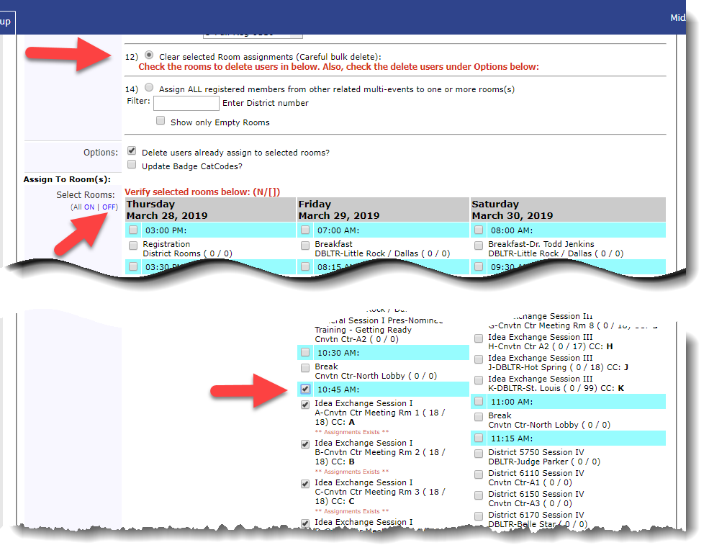
Figure 5

PE’s from Non-Native Districts
Once you’ve completed your final assignment based on club size, manually add PE’s, PN’s and PND’s who have registered from clubs not in the native MAPETS districts. DACdb’s room assignment routine doesn’t have access to the club sizes for these clubs so it can’t assign them to the correct club sized room.

Copy room assignments to subsequent Idea Exchange Sessions
Once the assignments are completed for the Idea Exchange Session I rooms, you are ready to copy these assignments over to Sessions II and III. This is done by first changing the room capacities in Idea Exchange Sessions II & III to be the same number of members assigned to each room in Session I. The important point here is if, for example, the Session I room “A” has 19 members assigned to it and the same room in Session II has a capacity of 18, the system will only copy 18 members to the Session II room and will push the 19th member to the next room which will create problems in all subsequent room assignments.

Each room’s assigned members are copied from the source room to the target room using
Option: 6) Copy (clone) Members from one room to another room (Rotaracts to other rooms):

In the “from Room:” field Select each room starting with Idea Exchange Session I-A (each room’s members must be copied / cloned one room at a time.) (See Figure 6 below)

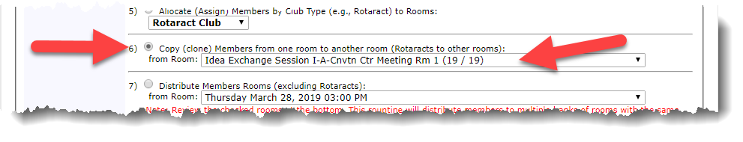
Figure 6

Scroll to the bottom of the screen and click Select Rooms OFF to deselect all rooms.
Select the Idea Exchange Session II-A room in the list of room (the target room)

Each Idea Exchange Session room’s members must be copied one room at a time from Session I to Session II and then start over again copying each room in Session I to Session III.
(See Figure 7 next page)

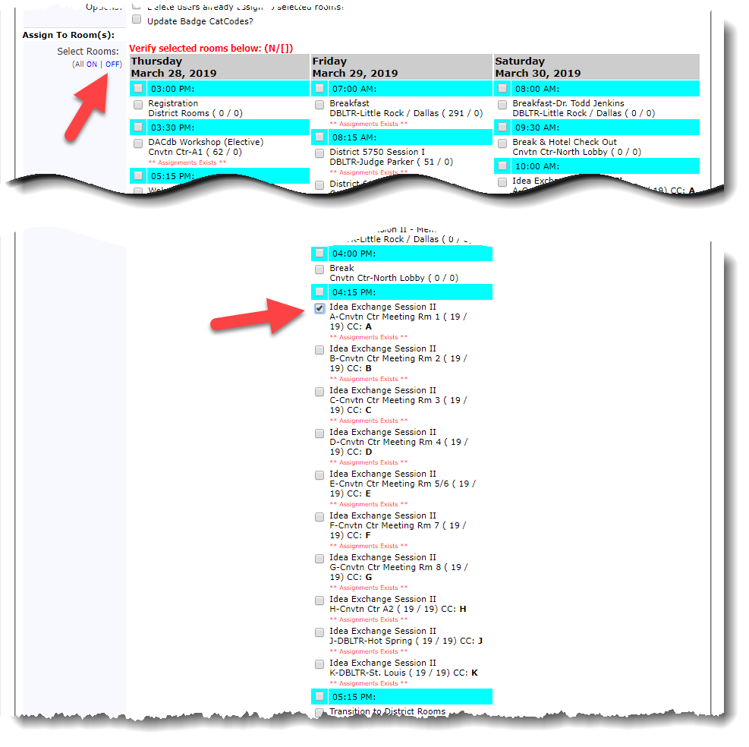
Figure 7

Repeat these steps for every room in Idea Session I by copying the members to each matching room in Session II. Then repeat the steps again copying the members in each room in Session I to the matching room in Session III.

Apply ROOM CatCodes to Badge

This step copies the room codes assigned to each room to the CatCode field in the backroom for each member who has been assigned to an Idea Exchange Room. Note the CatCode field is not visible in the backroom by default. It must be added using the gear wheel configure tool in the Backroom.

From the Event Rooms Listing screen click on the “Apply ROOM CatCodes To Badge” button
(See Figure 8 below)

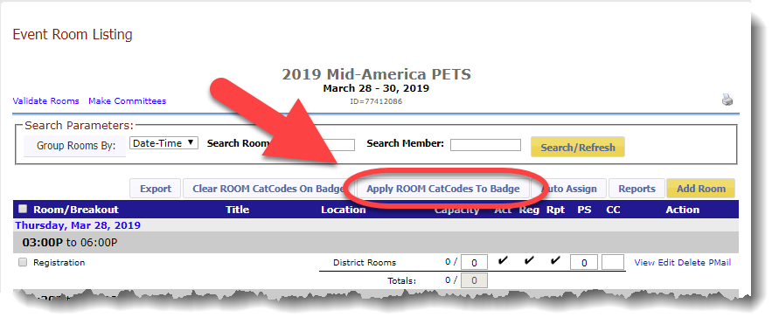
Figure 8

De-select (Select Rooms - OFF) to uncheck all rooms, then check the highlighted bar with the time for Idea Exchange Session I to check all the rooms for that time. (This only works if there are no concurrent sessions for other members such as a PDG Reunion held at the same time as an Idea Exchange Session – if that’s the case be sure to uncheck the unrelated concurrent session’s room.)
(See Figure 9 next page)
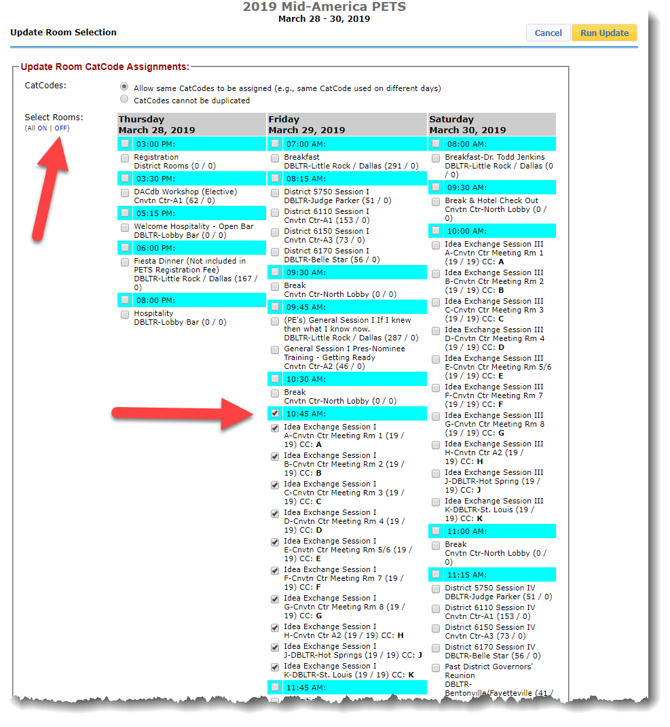
Figure 9

Clear ROOM CatCodes on Badge

If, after you’ve Applied Room CatCodes to Badges you find you need to go back and reassign members to rooms you can clear the CatCodes from the CatCode field in the backroom and Apply again prior to printing name badges. Note, at the top of the Event Room Listing screen you’ll see a “Clear ROOM CatCodes On Badge” button on this screen. (see Figure 10 below)

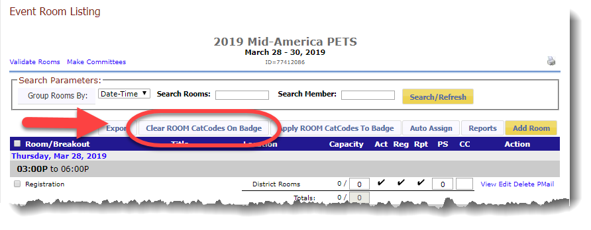
Figure 10

Assign members to other rooms

The following sections explain how to assign members to their general sessions, district sessions, common agenda items such as breaks, and the optional sessions such as the DACdb workshop, PDG Reunion, Thursday dinner, Friday Breakfast etc. This will allow members to view their personalized “My Agenda” schedule in the MyEvent app and give them clear access within the MyEvent app to the individual surveys for each of their sessions.

General Session (attended by all registrants)

Option: 0a) Allocate (Assign) ALL registered Members to checked Sessions (e.g. General Sessions))
Once this option is selected, you’ll see a complete list of all rooms associated with the event at the bottom of the screen.
Carefully select all rooms / sessions that every registrant will attend but be sure to exclude any optional rooms / sessions as well as the Idea Exchange Sessions or District Sessions. Your selections might look something like the example below. (See Figure 11 next page)

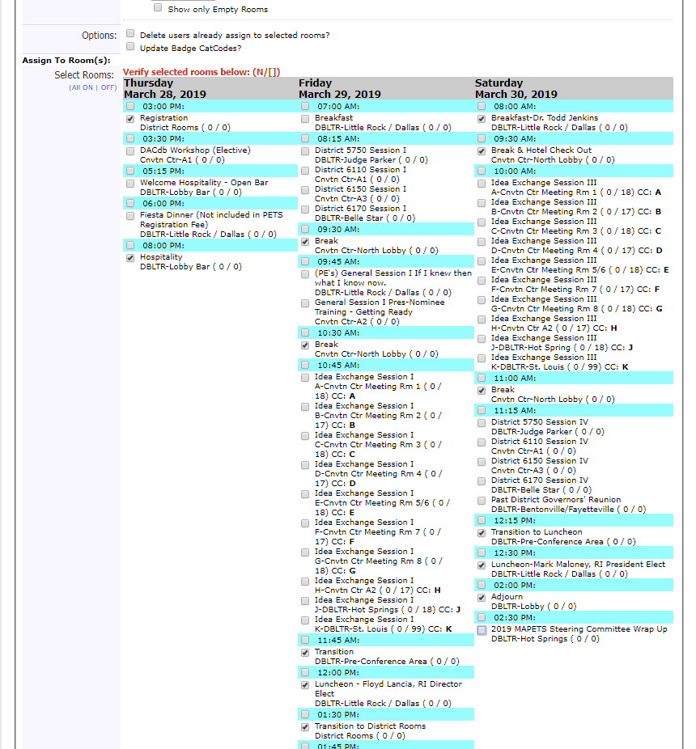

Continued next column

(Figure 11)

District sessions

Option 14) Assign ALL registered members from other related multi-events to one or more rooms.

Enter a District number into the field and DACdb will search all available rooms / sessions for a description that includes the entered district number. This selection usually works well depending on the rooms’ description field. To be sure, review the “Assign To Rooms” section to make sure only the district sessions that should be selected are indeed selected. Make any necessary adjustments and click the “Run Assignment” button. Repeat this process for each native district. (See Figure 12 below)

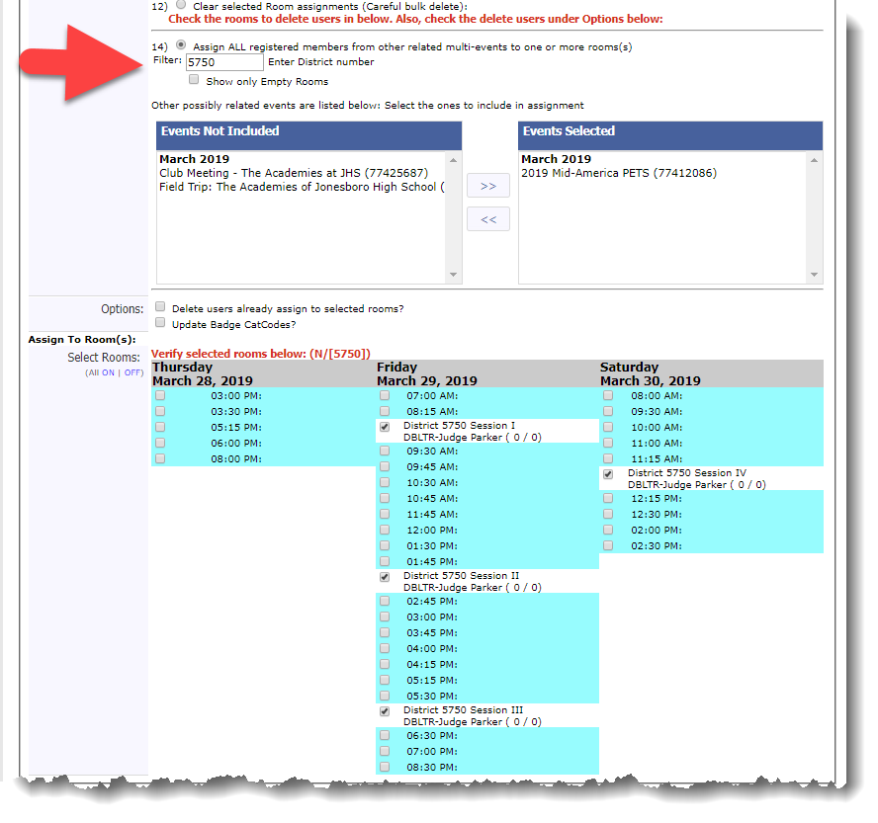
(Figure 12)
Note: Members from Non-Native districts will need to be manually added to one of the districts’ sessions.

Assigning Members to Electives

To assign members to elective session(s) such as an optional workshop, meal or session, use option:
11) Random assign ALL registered members to room(s) based on Question:

For an elective workshop with a specific question with a backroom value of “Yes” (See Figure 13 below)

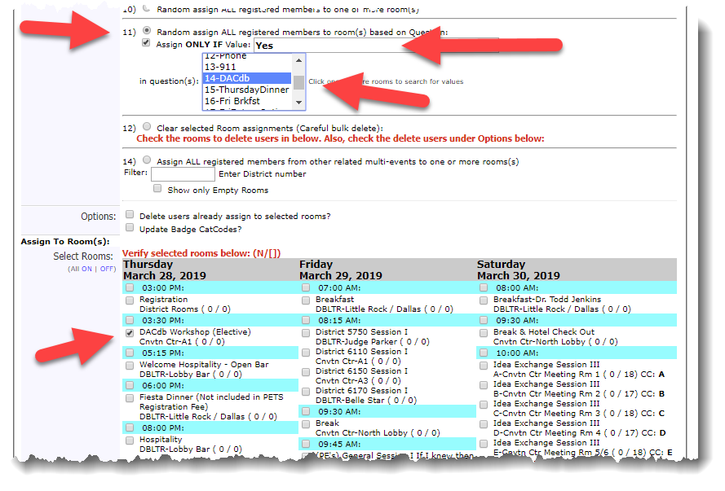
(Figure 13)
You’ll use the steps above to assign members to the Thursday evening dinner and the Friday morning breakfast. Each elective will need to be processed individually.

PDG Reunion
The PDG Reunion is a bit more complex because two values in the backroom indicate the registrant plans to attend the PDG Reunion – “MAPETS+” and “PDG” located in the “Event” question.
Option 11) Random assign ALL registered members to room(s) based on Question:
(Figure 14 below)

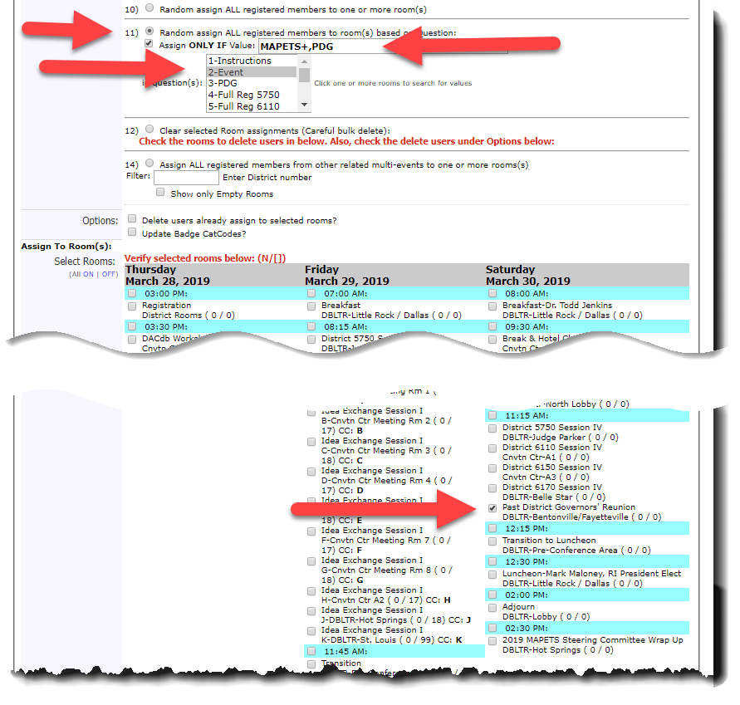
(Figure 14)
You could also use this approach to assign members to the Saturday luncheon but it appears every PDG who registered as such is attending the luncheon so that event could be assigned to everyone in the General Sessions option previously described. If you ever have a situation where a PDG registers for the Reunion but not the lunch, the method on this page could be used or you could simply manually remove the PDG who is not eating lunch from the luncheon “room”.

General Session I (Concurrent sessions with PN’s and PND’s in a separate session)

This one is the more complex and most dependent upon consistent values in the backroom Full Reg fields for EVERY registrant. Every member MUST have one of the valid codes in their respective Full Reg field. The valid values are (these come from the backroom values written by the Full Reg questions):
AG, CExec, DExec, DG, DGE, DGN, DGND, GUEST, Lt Gov, MTM, PE, PN, PND, Staff

To assign every member except the PN’s and PND’s to the General Session I – If I knew then what I know now, use option 11) Random assign ALL register members to room(s) based on Question:
Assign ONLY IF Value: “AG,CExec,DExec,DG,DGE,DGN,DGND,GUEST,Lt Gov,MTM,PE,Staff”

Press and hold the Ctrl key while selecting all five Full Reg fields in question(s): (See Figure 15 below)
4-Full Reg 5750
5-Full Reg 6110
6-Full Reg 6150
7-Full Reg Outside
8-Full Reg 6170

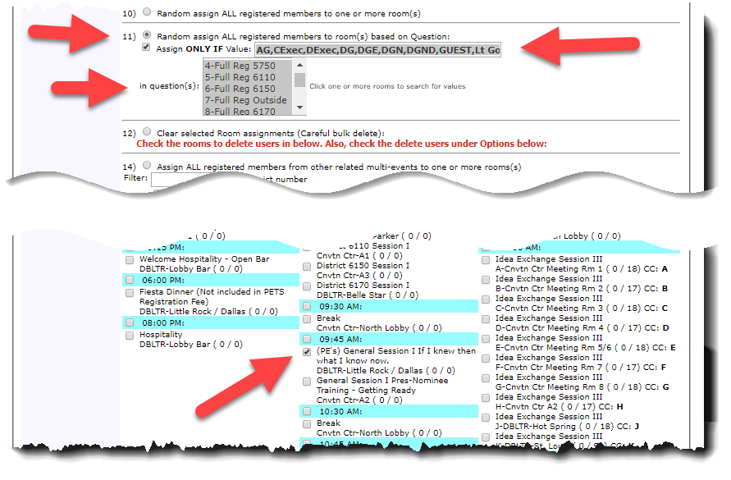(Figure 15)
To assign the PN’s and PND’s to the concurrent General Session I Pres-Nominee Training – Getting Ready room follow the same steps in the previous step with the Assign ONLY IF Value: “PN, PND” and select the corresponding room.

Option 11) Random assign ALL register members to room(s) based on Question:
Assign ONLY IF Value: “PN,PND”

Press and hold the Ctrl key while selecting all five Full Reg fields in question(s) : (See Figure 16 below)
4-Full Reg 5750
5-Full Reg 6110
6-Full Reg 6150
7-Full Reg Outside
8-Full Reg 6170

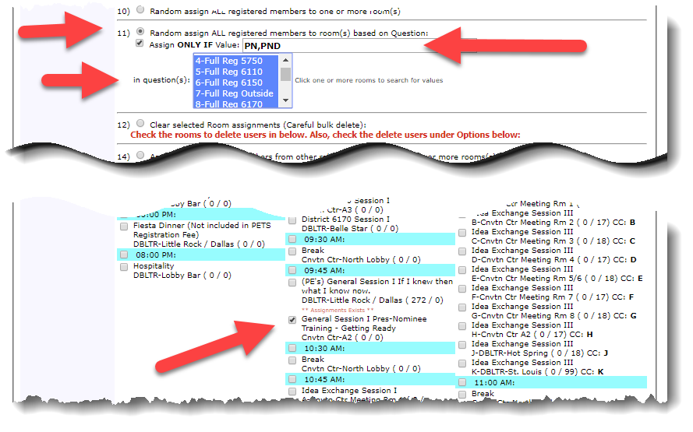
(Figure 16)

